Evaluating My Meetings

Instructions: Place a check in the corresponding column to the left of each statement as they apply to the meetings you conduct. 1- Always; 2- Regularly; 3- Sometimes; 4- Rarely

1 |  | 2 |  | 3 |  | 4  - I prepare and distribute an agenda prior to the meeting.  - I actively encourage all participants to contribute items to the agenda.  - I notify all invited participants at least two days in advance.  - I provide comfortable and adequate facilities and the necessary supplies.  - I start the meeting on time.  - I end the meeting on time.  - I ask someone to monitor the time to ensure all agenda items are discussed.  - I give each person a change to speak.  - I practice active listening.  - I summarize our progress or ask someone to do so.  - I make sure the meeting is not dominated by one person- even me!  - I give each person a voice in making decisions.  - I review commitments and accomplishments in my wrap-up comments.  - Participants give me feedback about the success of our meetings.  - Participants faithfully carry out all action agreed upon during the meeting.  - I provide a feedback/follow-up memorandum or minutes following the meeting.  - I follow up with participants on actions agreed upon during the meeting.  - I invite the right people and can count on them to attend.  - I include the group in decisions that affect them whenever I can.  - I ensure audiovisual equipment is in good working condition before the meeting.  TOTALS

Meeting Skills Checklist

Instructions: Each Statement below represents a valuable meeting skill. Learning to identify, practice, and improve these skills is part of being a team member. Check appropriate column for each statement indicating how often you practice that behavior. Your team may want to compare answers to find areas the team as a whole should be working on.

Behavior | Never | Occasionally | Often
1. I suggest a procedure for the group to follow, or a method for organizing the task
2. I suggest a new idea, new activity, new problem or a new course of action.
3. I attempt to bring the group back to work when joking, personal stories, or irrelevant talk goes on too long.
4. I suggest, when there is some confusion, that the group make an outline or otherwise organize a plan for completing the task.
5. I initiate attempts to redefine goals, problems, or outcomes when things become hazy and confusing.
6. I elaborate ideas with concise examples, illustrations.
7. I suggest resource people to contact and bring in materials.
8. I present the reasons behind my opinions.
9. I ask others for information and/or opinions.
10. I ask for significance and/or implications of facts and opinions.
11. I see and point out relationships between facts and opinions.
12. I ask a speaker to explain the reasoning that led him or her to a particular conclusion.
13. I relate my comments to previous contributions.
14. I pull together and summarize various ideas presented.
15. I test to see if everyone agrees with, or understands, the issue being discussed, or the decision being made.
16. I summarize the progress the group has made.
17. I encourage other members to participate and try to unobtrusively involve quiet members.
18. I actively support others when I think their point of view is important.
19. I try to find areas of agreement in conflicting points of view and try to address the source of the problem.
20. I use appropriate humor to reduce tension in the group.
21. I listen attentively to others’ ideas and contributions.
(c) Joiner Associates Inc. 1988. Permission to duplicate is hereby granted. 7-28.3
Before Meeting Checklist

- Determine if meeting is really necessary and hold meeting only if the answer to all the following questions is yes:
- Purpose of meeting is clear and cannot be handled by telephone or email
YES |  | NO |  | ACTION NEEDED
- Key participants are available
- Adequate data is available
- Subject of meeting is important

- Complete and send out announcement and agenda:
- Date, Start Time and End Time
- Meeting Title
- Place
- Objectives
- References/Background Materials
- Responsibilities
- Agenda

- Method for participants to receive telephone message, email, etc.
- Know how to logically introduce each item on agenda
- Insure meeting room is available and has necessary supplies, working equipment, and environment
- Have enough copies of materials
- Have appropriate seating arrangements
- Call each participant and answer any concern(s) and confirm attendance
- Have proper graphics and electronic files ready to use
- Meeting evaluation method
- Insure travel and lodging arrangements are completed for out-of-town participants

Meeting Arrangements Checklist

The following checklist summarizes typical meeting arrangements. Use it as a model for your meetings.

1. Tables and chairs properly arranged for the type of meeting to be conducted.

2. Table name cards for participants (if everyone is not well acquainted).

3. Audiovisual equipment required:
- Flipchart with Markers
- Laptop and/or Password
- LCD Projector and/or Screen
- DVD, VCR, or CD Player

4. Electronic files on CD or USB Drive (and back up)

5. Scheduled breaks for meetings longer than one and a half hours.

6. All necessary materials available such as handouts, notebooks, paper, pencils, and agendas

7. Refreshment as appropriate.

Adapted from Haynes, M.E. (1988) Effective Meeting Skills: A Practical Guide for More Productive Meetings. Crisp Publications.
Sample Agenda
Project Team: Meeting Date:
Meeting Purpose/Goals/Outcomes:

Times | Activity | Item Type  (decision, action, discussion) | Must do/  Should do? | Time Estimate (minutes)
 | 1. Icebreaker/Introduction
 | 2. Review Minutes from Past Meeting and Agenda
 | 3. Status reports on individual or team assignments
 | 4. Other Items
 | 5. Review project status
 | 6. Assignments for follow-up activities
 | 7. Upcoming events
 | 8. Review of items on the “Action List”
 | 9. Review of items on the “Futures List”
 | 10. Items for next agenda
 | 11. Special Activity
 | 12. Meeting Evaluation
 |  |  | Total Time

During Meeting Checklist

- START on time
YES |  | NO |  | ACTION NEEDED
YES |  | NO |  | ACTION NEEDED
- Insure everyone know each other
- Clearly define roles (leader, facilitator, scribe, timekeeper)
- Review purpose and objective(s)
- Walk-thru and revise agenda
- Maintain focus on objective/agenda
- Use active listening techniques during discussions
- Use vivid words that will make ideas stimulating
- Build trust and open relationships among members
- Help each speaker keep ideas concise and to the point
- Encourage all individuals to participate, become involved, and develop responsibility
- ___ accurate feedback follow-up memo is recorded
- Keep meeting discussion positive
- Summarize meeting in a positive manner
- Establish time, place and preliminary agenda for the next meeting

After Meeting Checklist

- Obtain completed attendance list
- Write Feedback/Follow-up Memo and disseminate it quickly
- Follow-up and Feedback-Follow-Up Memo to insure completion of action items
- Determine if meeting objectives were met
- Determine how next meeting can be even more effective
Roles of Team Members

The Role of the Facilitator
- Focuses on the meeting process
- Intervenes to preserve the meeting process
- Alerts the group when it strays
- Handles disruptive behavior:
  - Side conversations
  - Domination by one member
  - Rambling
  - Personal attacks
- Is a neutral “servant” of the group
- Does not evaluate contributed ideas
- Suggests alternative methods and procedures
- Encourages everyone to participate
- Helps the group find win/win solutions
- Is positive- compliments the group
- Does not talk too much
- Helps to educate the group
- Does not talk too much
- Helps to educate the group
- Is not defensive
- Does not have the roles or responsibilities of a group member

The Role of the Leader
- Sees that the group performs its duties
- Is accountable for the quality of the decision of the group
- Gives the group direction
- Assists the group in setting goals, objectives, and plans
- Assigns tasks and responsibilities to members
- Presides over formal voting
- Is a group member
The Roles of the Scribe
- Captures basic ideas on flip chart
- Does not edit or paraphrase unless given permission to do so
- Labels all sheets
- Is not always necessary
- Usually is a group member

The Role of the Time Keeper
- Monitors how long the group is taking to accomplish its tasks
- Provides regular time updates
- Is also a group member

The Role of the Group Member
- Keeps the facilitator neutral and out of content discussion
- Makes sure that ideas are being recorded accurately
- Focuses energy on the content of the problem
- Respects other members
- Listens to members
- Keeps an open mind
- Does not engage in disruptive behavior:
  - No side conversations
  - No domination
  - No ramblings
  - No personal attacks

Disruptive Group Member Roles
Can block process or content

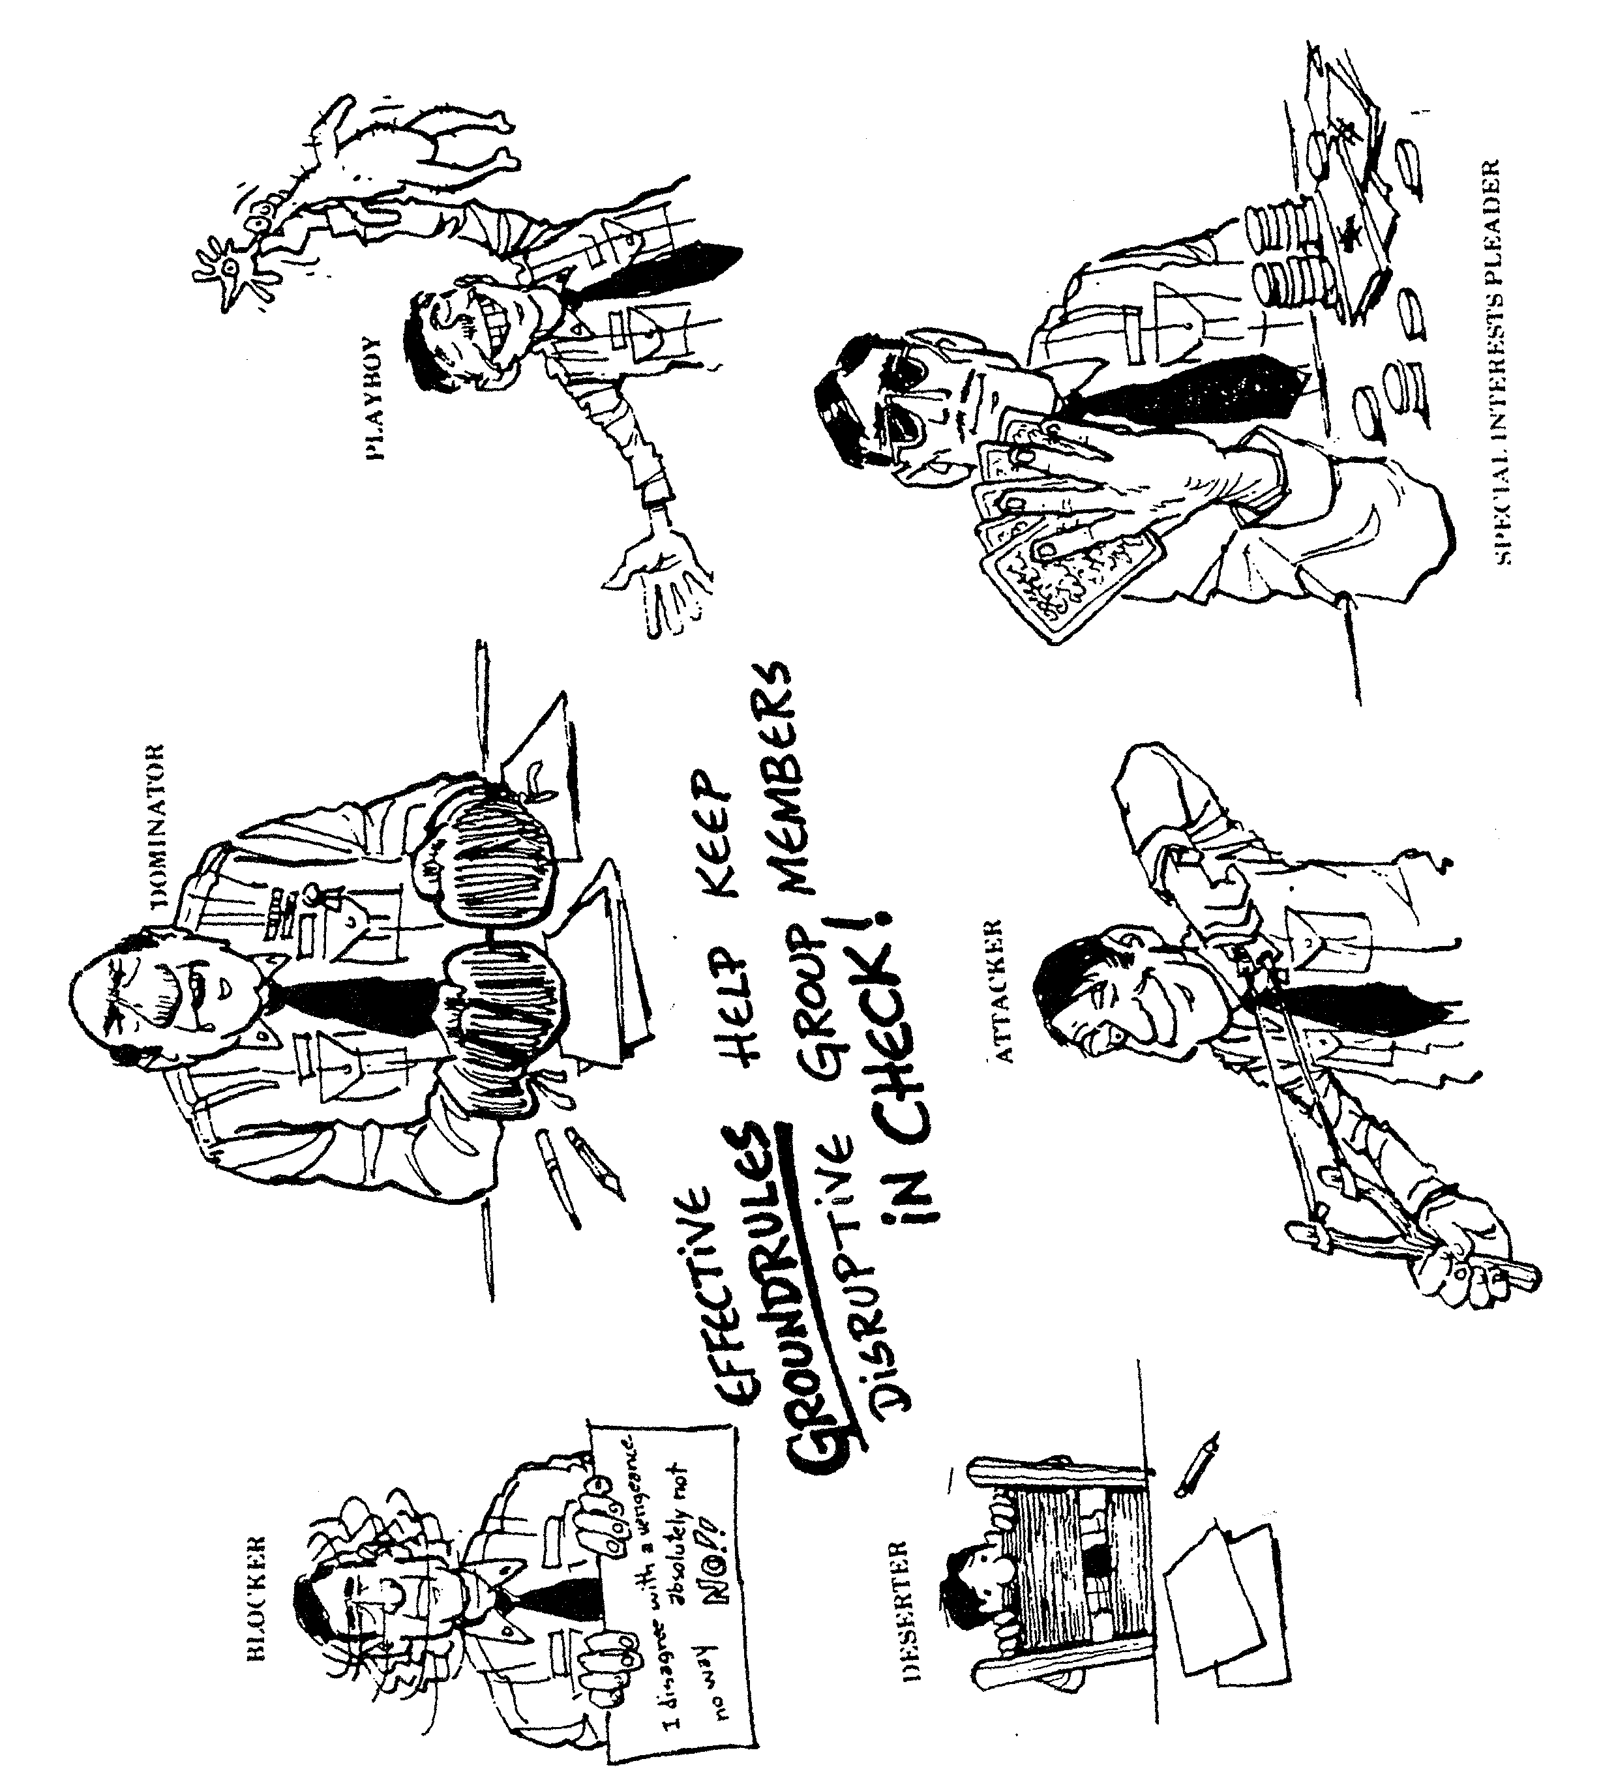

Blocker: Being critical, negative, and resistant; opposing, and disagreeing without or beyond “reason;” attempting to maintain or bring back an issue after the group has rejected or decided to bypass it
Attacker: Deflating the status of others; expressing disapproval of the problem being worked on; showing envy towards another’s contribution by trying to take credit for it.
Playboy: Displaying lack of involvement in a group’s processes by cynicism, nonchalance, horseplay, showing off, or storytelling.
Deserter: Withdrawing from discussion; being indifferent, silent, aloof, excessively formal, or a day dreamer; talking deliberately about own experiences when unrelated to discussion of group.
Special Interests Pleader: Speaking for others; cloaking personal prejudices in order to achieve individual objectives.
Dominator: Asserting power or superiority to manipulate the group or certain members of the group; asserting a superior status or right to attention; giving directions autocratically; interrupting the contributions of others.
Facilitator’s Post Meeting Coaching Checklist
Take time to evaluate how the meeting went. What did you observe and what needs to be addresses?

Meeting Objectives:
Notes:
Notes:
Notes:
Notes:
Notes:
- Was the purpose achieved?
- How did the members feel about the meeting?
- Share your observations

Leader’s Impact on Meeting:
- How did you feel about your leadership in the meeting?
- What part of the meeting did you handle best?
- Share your observations.

The Group’s Dynamics:
- How effectively did the group work together?
- What aspects of teamwork do you wish were better?
- How could you or I intervene to improve that aspect of teamwork?
- Share your observations.

Explore Your Relationship:
- How do you feel about the interventions I made in the meeting?
- Were there situations where I should have intervened, but I didn’t? When? How?

Review Next Steps:
- What are the follow-up items for the next meeting?
- Who will be responsible?
- When will we plan the next meeting?
Project Closure Checklist
Instructions: Use the checklist and questions to help decide what tasks your team needs to complete to end the project. Discuss with your team what it will take to finish those tasks.
Yes No
□ □ Is your team’s work done?
□ □ Was the mission accomplished?
□ □ Have improvements been standardized and error-proofed?
□ □ Is your team’s document file (meeting, records, etc.) complete?
□ □ Has a final report been made to the management team or supervisor?

Evaluate the Team’s Process
- What was it like working with this team early on?
- What have you learned from this experience?
- What advice would you give to other teams?
- How well did you work with your supervisor?
Evaluate the Team’s Product
- What helped the team accomplish its mission?
- What stood in the way of the team accomplishing its mission?
- What were the team’s technical accomplishments?
- How will improvements be maintained?
- How were improvements communicated among and between work groups?
Communicating the Ending
- How will the team’s improvements be communicated to the rest of the organization?
- What other projects will be developed as a result of this project?
- How will this team’s learnings be communicated to management?
- What recommendations will the team make for follow-up after the project is over?
The Celebration
- How will the team’s closure be celebrated?
FEEDBACK/FOLLOW-UP MEMO

Group/Department: Date:
Meeting Purpose:
What Happened & How:

Decision/ Person(s) When to Complete/:
Action Items: Responsible: Deadline

Next Step(s)/Meeting(s):
This Memo Distributed to:

